Students' Health Service Annual Patient Survey 2022/23

In December 2022 we asked the PPG (Patient Participation Group) members to help design the questions for the SHS Survey. From this the patient survey was formed to gather opinions on several key areas such as the appointments system post-Covid, the website (which has recently been updated to be more user-friendly), our use of SMS messaging, and potential use of extended access appointments at weekends.
We had 206 respondents in total (similar to previous years; 253 in 2020/21 and 249 in 2019)

In the survey 75% of respondents advised that they had a longstanding health condition and 25.7% regarded themselves as having a disability.
This compares with the last survey when the breakdown was 28.9% with longstanding health conditions and 14.6% identifying as disabled. This may reflect that such respondents use our services more and may be more likely to have formed an opinion It could also reflect that respondents in these groups might be more likely to have an in-person appointment and see the feedback posters and QR codes in the waiting room.
Of the survey respondents, 77% were UK Nationals, 4.9% from the EU and 16.5% international students from outside the EU. This reflects figures provided by the University which record a that 25% of its student population are international students from outside the EU.
General feedback on the survey for next time: avoid having to put answers or add a “not applicable” box for sections that may not be relevant to every individual.

Telephone consultations
We asked; are telephone appointments more or less convenient than face to face appointments? Tell us about your experience of telephone consultations.
Comments included:
- “The phone appointments are great and much more convenient, I’m someone who has a long-term health condition and I find these make managing it a lot easier”
- “I'd like it if I was offered in person as well - more thorough in person. Telephone appointments are convenient though”
- “Telephone consultations were okay for some things, such as discussing my migraine medication, but when it came to personal conversations regarding mental health issues then just speaking over a phone did not seem the appropriate environment for disclosing very sensitive and personal information.”
- “My telephone consultations have felt very rushed, I’ve been called at times other than my appointment and had to miss a few. I do not feel listened to or allowed to express my thoughts as they are so quick.”

- “My issue seemed to be disregarded and I felt it wouldn’t have been that way if I’d have been there in person”
- “I found telephone consultation inconvenient because I am not a native English user, I could not show my medical records to the doctor, and I felt more nervous than in person conversation”

Summary of advantages of telephone consultations:
- Flexible
- Convenient (55%)
- Great if away from Bristol
- Fast and can be timesaving e.g., medication reviews
- Felt to be useful for anything that does not require seeing in person
- Can be less anxiety-inducing than waiting in the waiting room

Summary of disadvantages of telephone consultations:
- Problems with poor mobile signals - students often need to wait outdoors to receive the call which is not practical if clinicians are not calling at a specified time.
- Timing of calls for routine surgeries: Calls being made earlier than the predicted timeslot and then being marked as “missed”
- Some calls being made much later than planned when students may have other commitments such as lectures or work.
- Feeling rushed and not listened to over the telephone.
- Feeling a face-to-face would be more appropriate.
- Not great for mental health issues.
- Can feel like a less thorough assessment.

Texting system

We asked: We have introduced a texting system called Accurx. Have you found this way of communicating with the practice useful?
AccuRx texting has been taken up with enthusiasm by all teams in the practice and is used to let students know about appointments, test results, services, and signposting to resources.
Overall students found it “very or quite useful” = 77%
Only 1% had used the service and not found it useful.

Website
We asked: Do you use the Students’ Health (SH) Service website? Do you have any suggestions to improve the website?
Only 61% had used the SH website (several didn’t know we had one)
Of those 67% had found it easy or very easy to use.
67% had found it helpful or really helpful.
- “Contact details fairly easy to find and accurate.”
- “The web page has already all valuable information and easy to use.”
- Students wanted to be able to book appointments online directly, and also to be able to upload documents to their records. With the current level of appointment demand this isn’t possible except by using our online Patient Triage or email.

- Action points from the last survey included improving the clarity of information and instructions for online access and launching a more effective and concerted campaign to promote this facility to patients. The website has been edited heavily to make the online services more visible, for example for ordering medication and for requesting admin support. This has only been completed in the last 3 months and further refinements are planned.

Suggestions for website content and formatting:
- “There could be easier access to some of the mental health and well-being
services - including the workshops run, or self-care tips”
- “Make it easier to read and more accessible”
- “Lots of links are in the text- more boxes to draw the eye”
- “Black background for dyslexics” (unlikely to be possible as we are tied to UoB styles)
- “More information and support for those anxious about visiting/ booking appointments e.g., autistics”

Profile and gender

We included a number of profile questions to ensure we had feedback from all student groups. As part of this we asked: How easy did you find it to make changes to your record of gender identity at Students' Health Service? And do you know you can update your Medical Record to use your preferred pronouns?

Since the last survey the gender page on the website has been updated, the rainbow flag is on the home page and most staff wear rainbow lanyards and rainbow NHS badges. Most staff have added a pronoun choice to their email signature.

77.1 % felt that their gender and pronoun choices had been respected at Student Health, (an increase from the previous survey 62.5%) A further 17% felt this was not relevant to them and 5.7 % felt that it had not been respected (= 2 respondents)

73.1% felt that making changes to their record of gender was very easy or easy.

Only 19% were aware that they could update their pronouns (but 68% replied this was not relevant to them)
This is similar to the last survey (21.3%) and we again included information on how pronouns can be updated within the survey. Overall SH are doing well, but there is room for improvement. In particular, we will make it clearer that pronouns can be updated.

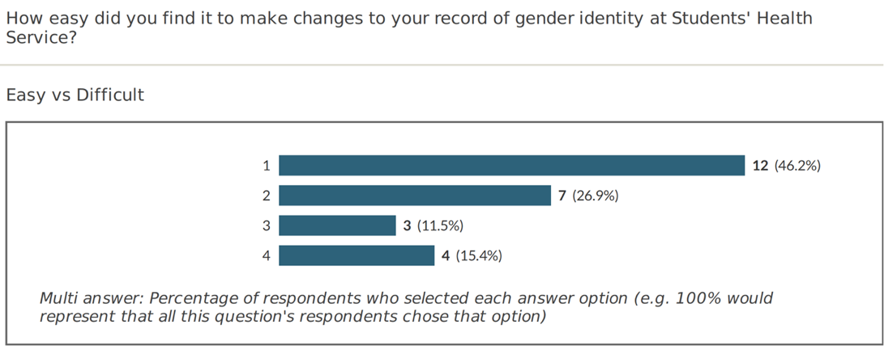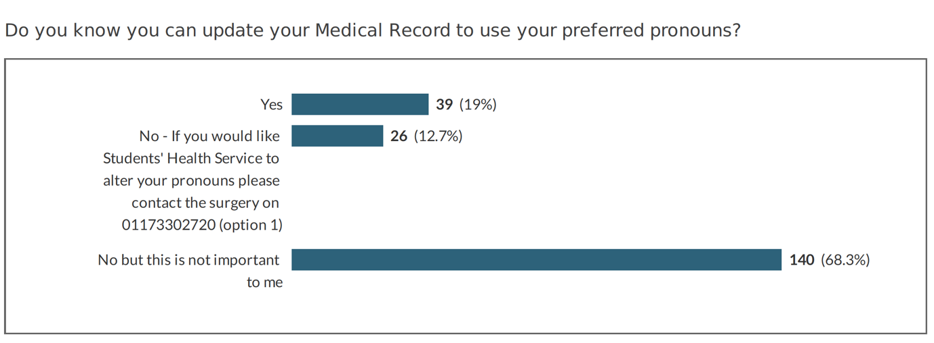

Timing of appointments (extended hours)
We asked: Do our extended access appointments suit you, and what other times would you use?

87.9% would use Saturday morning appointments, which we already offer.
88.3% evening appointments, which we also offer.
Smaller numbers for other times as below.
Of note: the least popular time would be 7-8 am but it would still suit 35.9% of respondents.
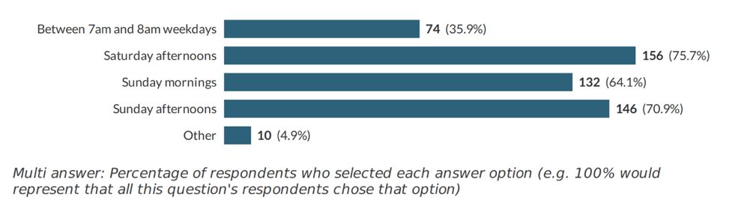

Outcomes

- Telephone appointments. A unified approach to telephone appointments has been discussed and agreed. When booking, we will send a text informing patients that we will try at least twice and will also send them a text.
- If a clinician has been unexpectedly delayed e.g., due to an emergency, the AccuRx text: “delay” can be used to inform the patient that their phone call will be delayed.
- Patients will be offered a choice of telephone appointments or in-person appointments. Clinicians may wish to consider offering face to face appointments more often for mental health issues.
- Extended access appointments are already being offered at the most popular times, but the survey can help us decide which other times are best if we extend our offer.
- Website alterations have been made. For example, the contacts page, booking appointments and medication page are easier to navigate and more mental health resources have been added.
- The webpage on our site covering Gender and Sexuality has been updated to include guidance on private care, the new rainbow flag and updated self-help resources. We will also extend waiting room decorations to include religious and cultural events from other faiths e.g. Diwali, Eid, Chinese New Year and Hannukah.
- We are liaising with the University IT team to advertise the student health website on our wating room screen.
- Posters showing inclusivity (“All are welcome here”) and more specifically inclusivity around gender and sexuality are now displayed in the waiting room. These include a prompt regarding “letting us know your pronouns.”
- Changes made as a result of the patient survey will be displayed in a “You said, We did” poster in the waiting room and on our website.

